version: | 2023-6-22

Instructions
The prompts in this self-inspection report are intended to collect key system installation characteristics, including photographs, which will allow Commerce Rhode Island staff and contractors to conduct a reasonable due diligence review, as a substitute for an onsite inspection. This report includes a self-inspection checklist and a descriptive photograph sheet. Installers wishing to complete a self-inspection must fill out all applicable fields, including all photos. Forms with missing information will be returned to the installer. In cases where multiple pieces of equipment (e.g., two different types of PV modules) are used, please copy/paste the relevant information into the table and fill it out for both sets of equipment. Installers are encouraged, but not required, to attach an as-built electrical design drawing to this report.
Once completed, please submit this form in PDF format via email to ref@commerceri.com.
For technical questions on completing this self-inspection report, contact QAInspections.RI@cadmusgroup.com.

System Information
Grant Number | #-###
System Owner Last Name | Smith
Installation Company | PV Installers Inc.
Installer Last Name | Jefferson
Person Completing This Report | Rogers
Phone | (###) ###-####
Email | email@address.com
Report Date | 1/1/2023

Self-Inspection Checklist

Array and PV Modules
Inspection Item | Value
System Capacity (kW_{DC}) | 10.0
System Lifetime Energy Production (kWh) | 12345
Module Quantity | 12
Module Manufacturer | Panels
Module Model Number | PV400
Modules per String (or per circuit for microinverters) | 10
Number of Strings per Input Circuit | 2
Conductor Size/Insulation Type | #10 AWG PV wire

Racking
Inspection Item | Value
PV Racking Manufacturer | PV Mount
Model | 12345

Microinverter
Inspection Item | Value
Quantity | 20
Manufacturer | MI’s R Us
Model Number | 12345

Optimizer
Inspection Item | Value
Quantity | 20
Manufacturer | Opti’s R Us
Model Number | 12345

Standalone DC Disconnect
Inspection Item | Value
Manufacturer | DC Disco’s R Us
Model | 12345

Backup Power System
Inspection Item |  | Value
System Type  (Select All Applicable Configurations if Multiple are present) | Entire Facility
 | Partial Facility | X
Dedicated Backed up
Subpanel
Dedicated Backed up
Subpanel
 | Entire Facility
 | Partial Facility | X
Location(s) |  | Garage

String Inverter
Inspection Item | Value
Quantity | 1
Manufacturer | Inverters Depot
Model Number | 12345

AC Combiner
Inspection Item | Value
Quantity |  | 1
Manufacturer |  | Combiner Depot
Model Number |  | 12345

AC Disconnect (Other than Interconnection) (Copy and Paste if Multiple)
Inspection Item | Value
Quantity |  | 2
Manufacturer |  | AC Disco Depot
Model Number |  | 12345

Energy Storage System
Inspection Item | Value
Coupling | AC or DC
Manufacturer | ESS Inc
Model | 123
Quantity | 2
Battery (If external how many units?) | Internal/External |  | Qty: 2
Total ESS Rating (kW and kWh) | Output Power kW: |  | Capacity kWh:
Gateway Model (enter N/A if not present) |  |  |  | N/A
Critical Load/Backed-Up Load Subpanel Busbar  Rating (A) (enter N/A if not present) | 125A
Critical Load /Backed-Up Load Subpanel Breaker Rating (A) (select MLO if main lug only or N/A if  not present,) | 25A
Location (enter N/A for not present) | Basement

Interconnection (fill in one of the three sections below)
 | Inspection Item | Value
SUPPLY SIDE CONNECTION | PV Service Disconnect
 | Manufacturer and Model
 | Fuse/Breaker Rating | Voltage: ###V | Current ###A
 | Conductor Size/Type | Line: #___AWG | Load: #___AWG
 | Point of Interconnection
Splice connector Location
(Main Panel, Utility Meter, Combined Meter Pan)
FEEDER TAP CONNECTION | Grid Side Circuit Feeder Overcurrent Device Rating | ###A
 | Grid Side Existing Feeder Conductor Size | #___AWG
 | Busbar Rating of Grid Side Panel | ___A
 | Breaker Rating of Load Side Panel  (enter MLO if main lug only) | ___A |  | MLO
 | (Only if MLO is selected above) Load side Busbar Rating |  |  | ___A
 | PV Disconnect
 | Manufacturer and Model
 | Fuse/Breaker Rating | Voltage: ###V | Current ###A
 | Conductor Size/Type | Line: #___AWG | Load: #___AWG
LOAD SIDE CONNECTION | Main Breaker Rating | _200_A
 | Backfeed Breaker Rating | _30_A
 | Panel Busbar Rating | 200
 | PV Conductor Size/Type | 10-3 NB Cable

Photos Required (Multiple photos may be needed)
Module Nameplate Photo
Insert Photo(s) Here
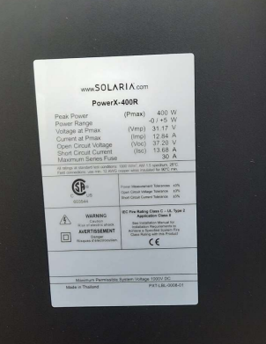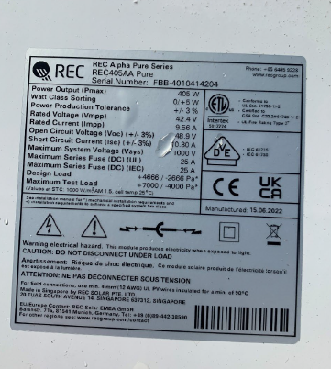
Notes:
Full Array Image(s)
Multiple photos may be needed to include all modules for verifying system capacity
Insert Photo(s) Here
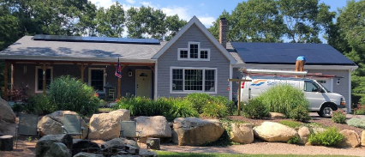
Notes:

Horizon Profile Photos
Take photos from the roof of the surrounding terrain to the (East, South, and West) of the Array(s). These photos should show all trees and other obstructions surrounding the PV array.
Insert Photo(s) Here
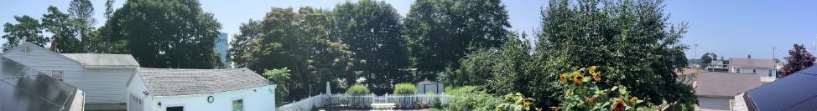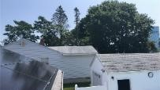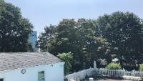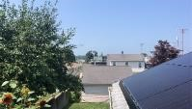
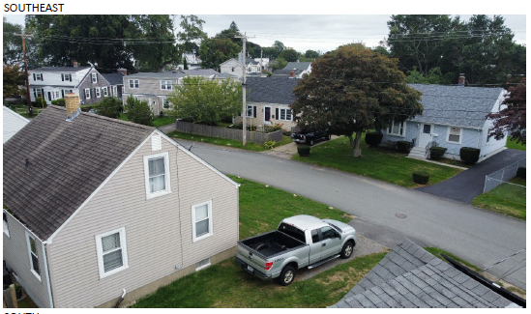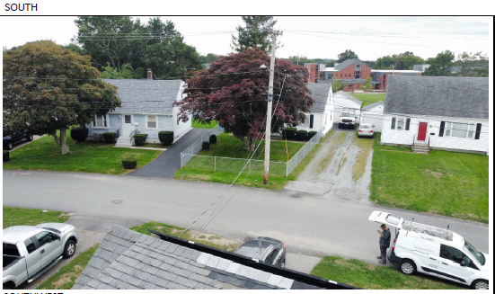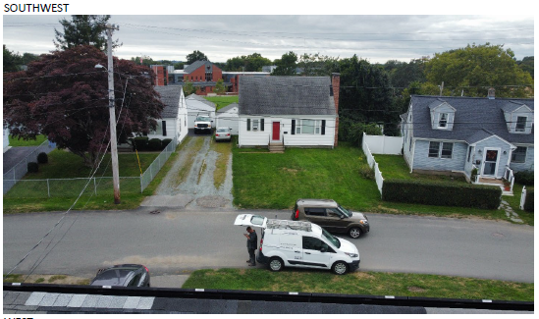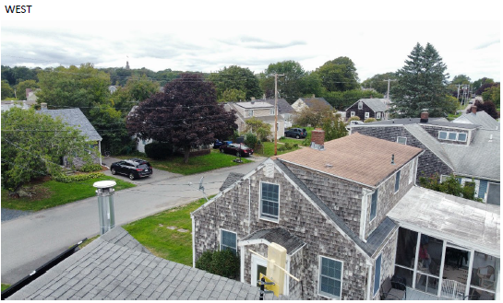
Notes:

Array Racking
Photo of the installed rails before modules are installed and after MLPE and ground wiring are completed
Insert Photo(s) Here
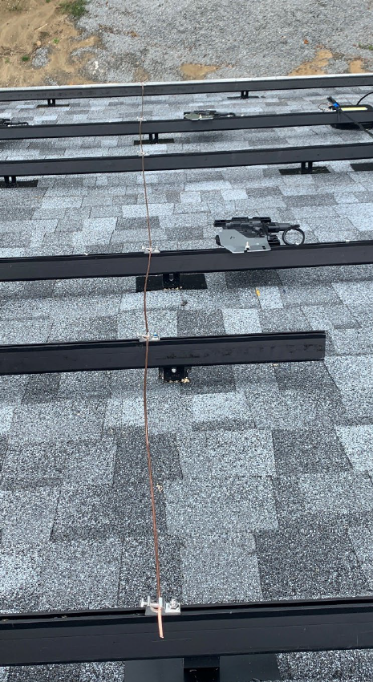 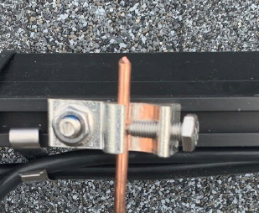
Notes:
Under-Array Wire Management
Close up photo showing the wire management under each array. Multiple photos may be necessary
Insert Photo(s) Here
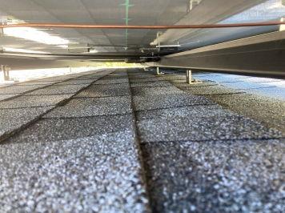 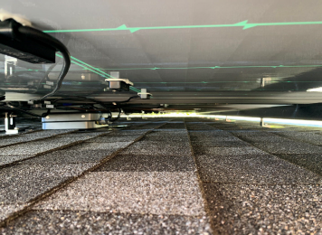
Notes:

Module Clamping
Show typical mid and end module clamp if applicable
Insert Photo(s) Here
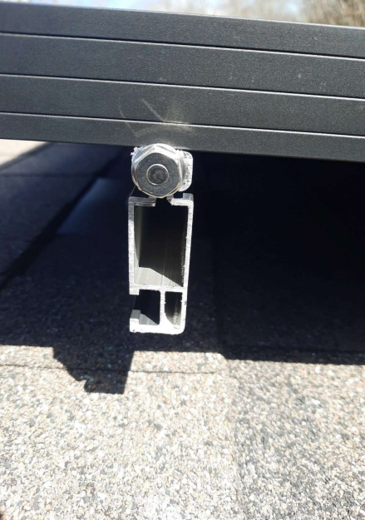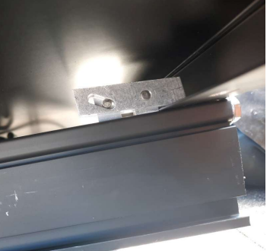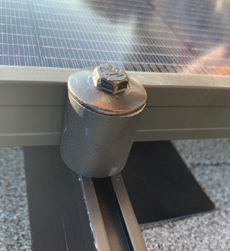

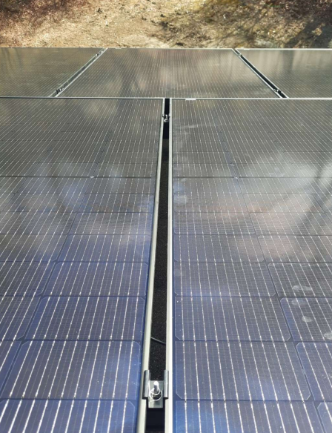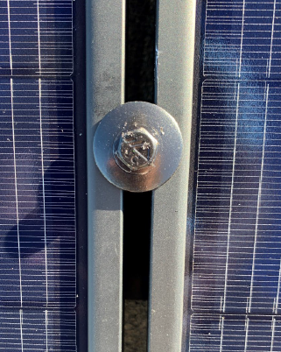
Notes:

MLPE Mounting- (Module Level Power Electronics-(Microinverters or Optimizers))
Show installed mounting bracket
Insert Photo(s) Here
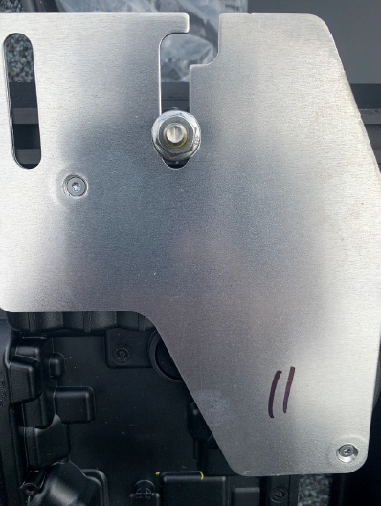
Notes:
MLPE Nameplate Photo
Insert Photo(s) Here
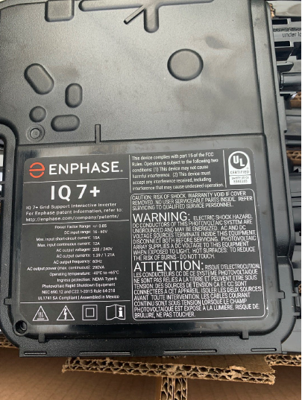
Notes:

Standalone DC Disconnect Wiring
Show wiring details
Insert Photo(s) Here
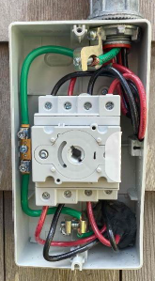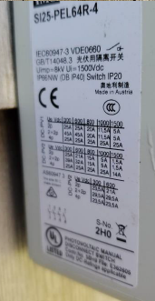
Notes:
String Inverter Exterior
Show sufficient detail to verify labeling
Insert Photo(s) Here
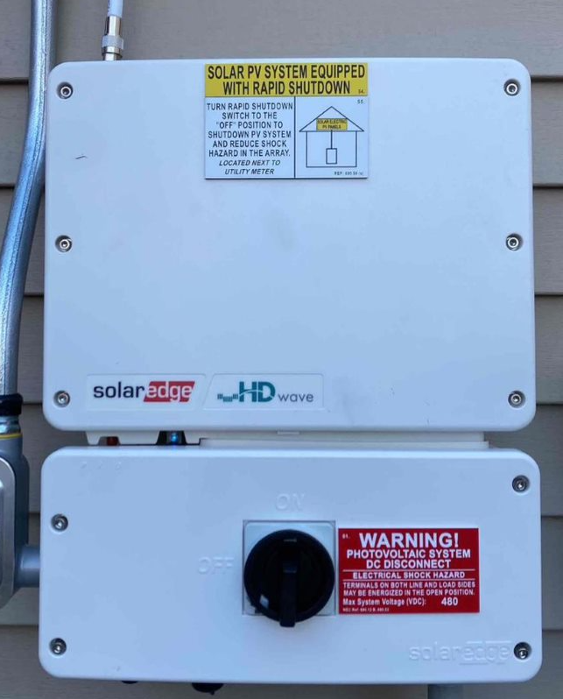
Notes:
String Inverter Nameplate Photo
Insert Photo(s) Here
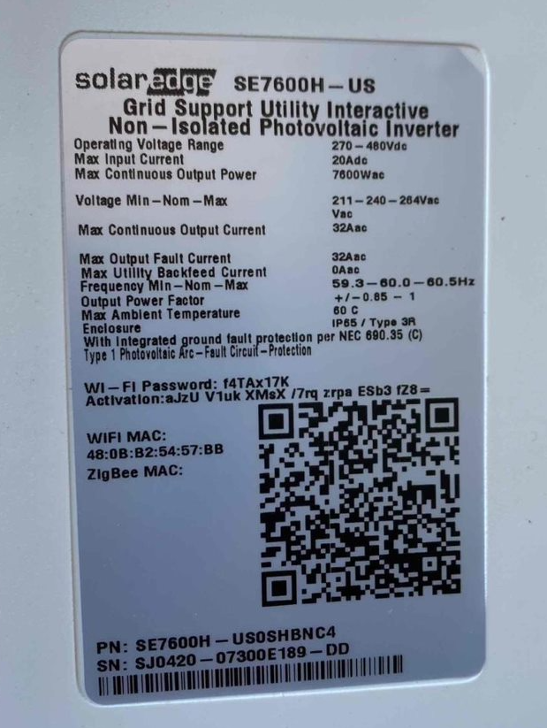
Notes:
String Inverter Wiring
Show all wiring terminations
Insert Photo(s) Here
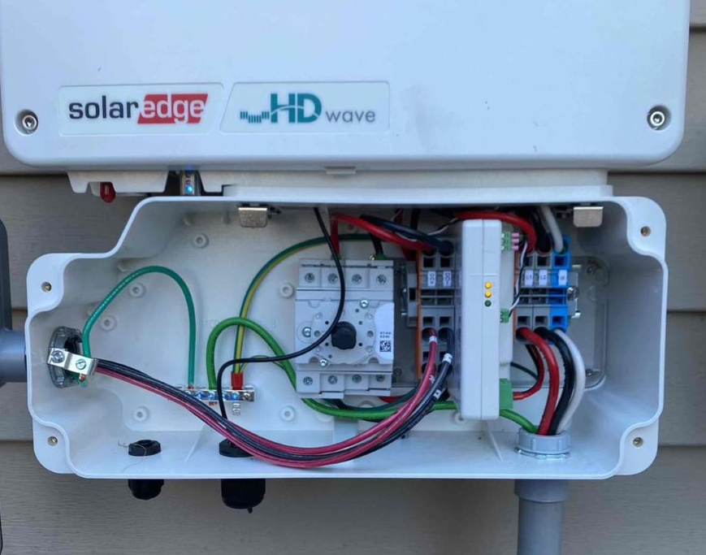
Notes:

AC Combiner Exterior
Nameplate and labeling details
Insert Photo(s) Here
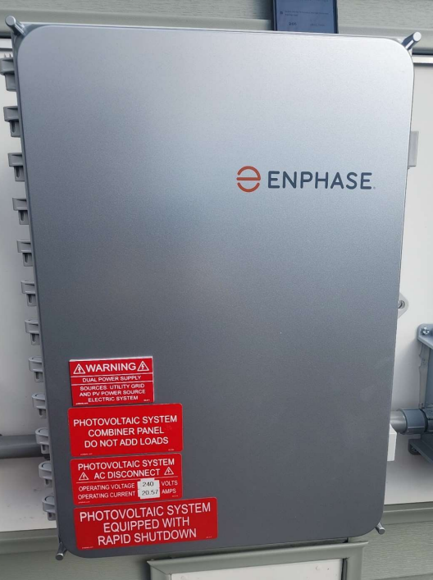
Notes:
AC Combiner Front Panel
Show front panel unique descriptive breaker/circuit ID. labeling
Insert Photo(s) Here
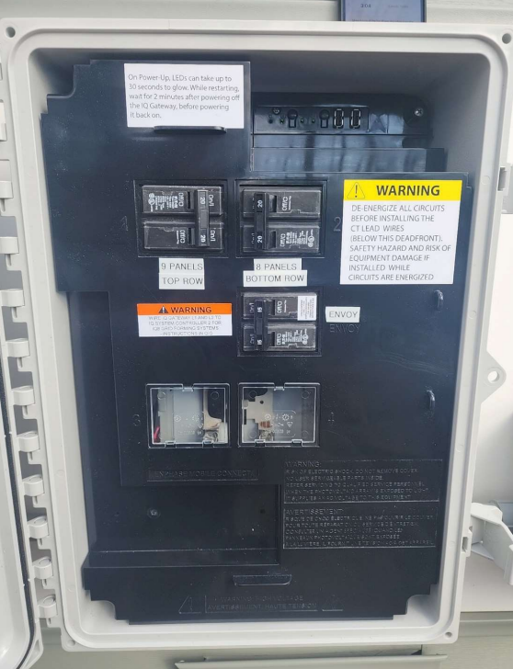
Notes:
AC Combiner Wiring
Show nameplate and all wiring details and terminations
Insert Photo(s) Here
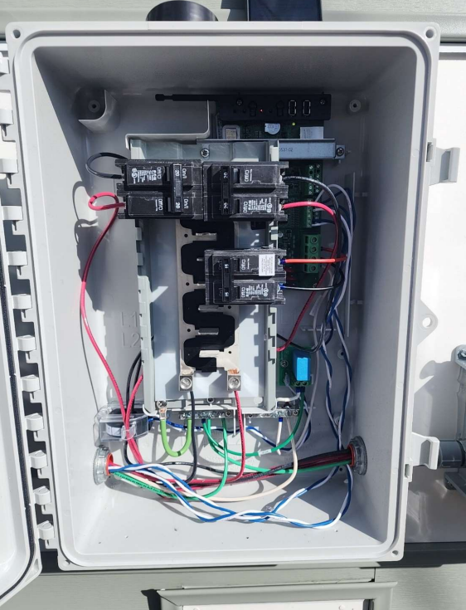
Notes:
ESS Gateway Exterior
Show gateway enclosure and proximity to disconnects.
Insert Photo(s) Here
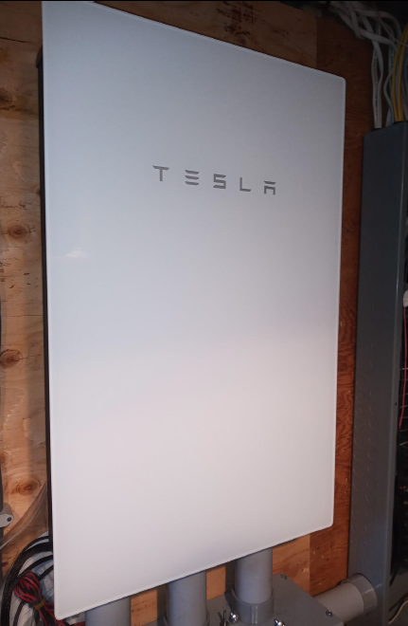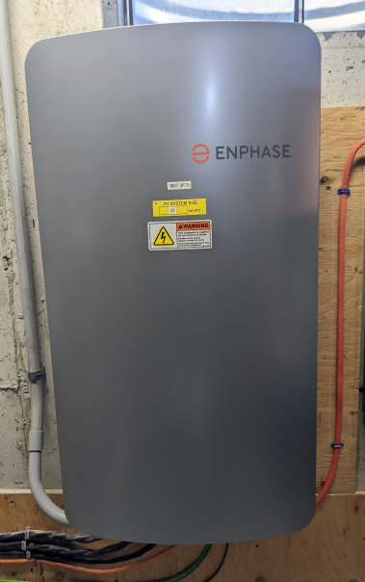
Notes:
ESS Gateway Nameplate and Front Panel labeling photo(s)
Insert Photo(s) Here
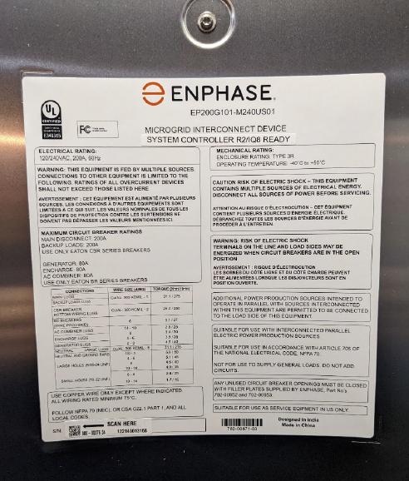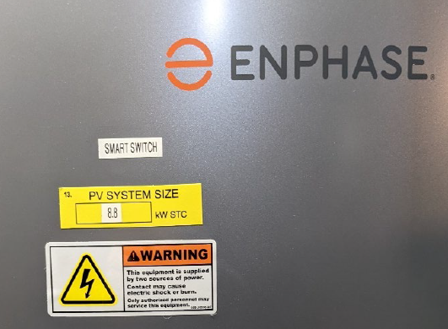
Notes:

ESS Gateway Wiring
Show all wiring details and terminations. Multiple photos may be needed.
Insert Photo(s) Here
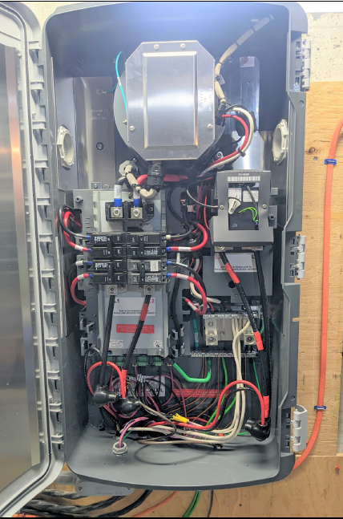
Notes:
ESS & PV AC Combiner Panel Exterior
Show Exterior and Front panel labeling. Multiple photos may be needed.
Insert Photo(s) Here
Notes:
ESS & PV AC Combiner Panel Nameplate and Wiring Photo(s)
Show all wiring details and terminations. Multiple photos may be needed.
Insert Photo(s) Here
Notes:

Critical Loads/Backed-Up Loads Subpanel
Show labeling with door closed and open. Multiple photos may be needed.
Insert Photo(s) Here
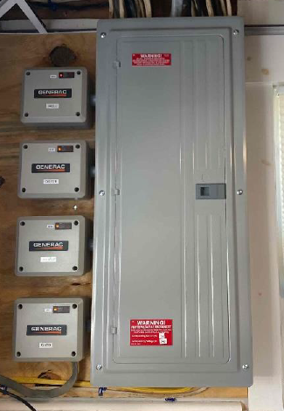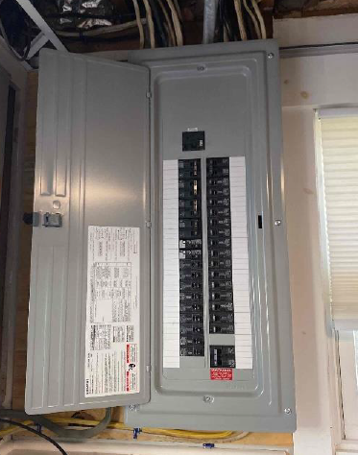
Notes:
Critical Loads/Backed-Up Loads Subpanel Wiring
Nameplate photo ,Show wiring details and terminations. Multiple photos may be needed.
Insert Photo(s) Here
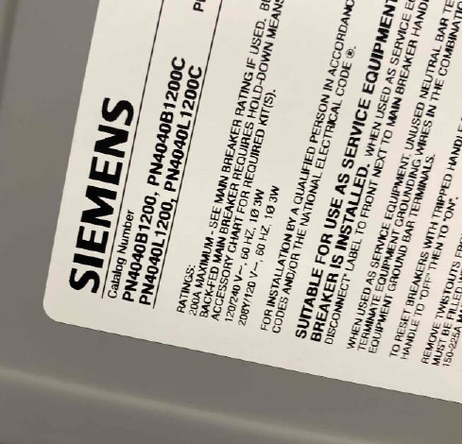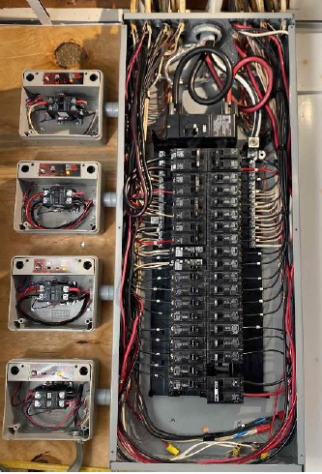
Notes:
ESS/Battery Exterior
Show enclosure and proximity to disconnects.
Insert Photo(s) Here
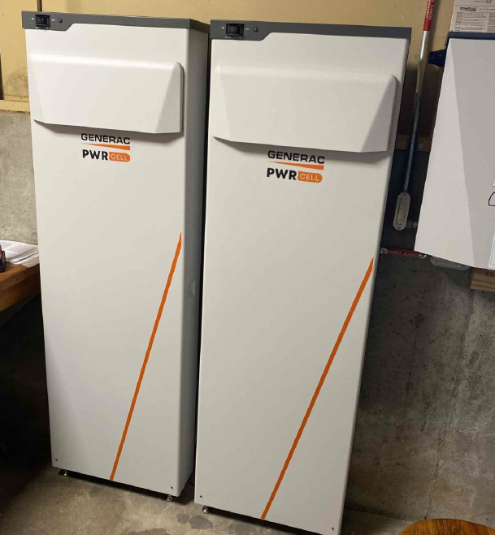
Notes:
ESS/Battery Nameplate
Insert Photo(s) Here
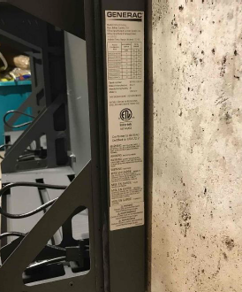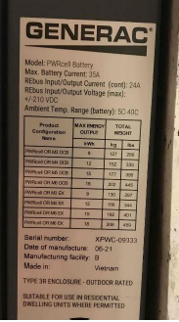
Notes:
Battery Pack/Bank (External)
Show all wiring details and terminations. Multiple photos may be needed.
Insert Photo(s) Here
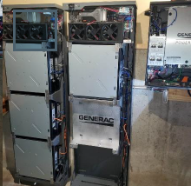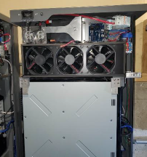
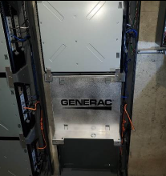
Notes:

Battery Wiring
Show all wiring details and terminations. Multiple photos may be needed.
Insert Photo(s) Here
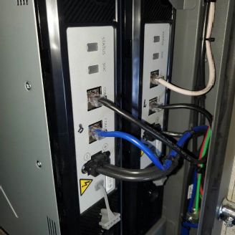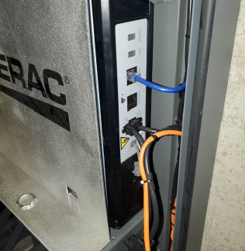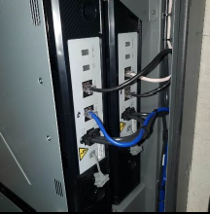
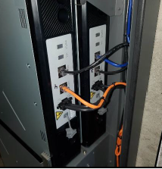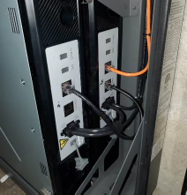
Notes:
Production Meter Exterior
Show production meter enclosure, nameplate ratings, and production reading
Multiple photos may be needed
Insert Photo(s) Here
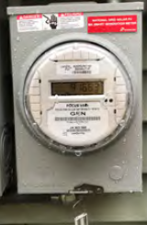
Notes:
Production Meter Wiring
Show wiring of production meter enclosure
Multiple photos may be needed
Insert Photo(s) Here
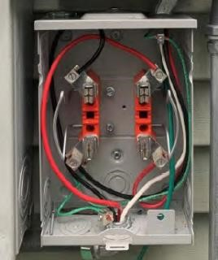
Notes:
Standalone AC Disconnect Exterior
Show nameplate/labeling details
Insert Photo(s) Here
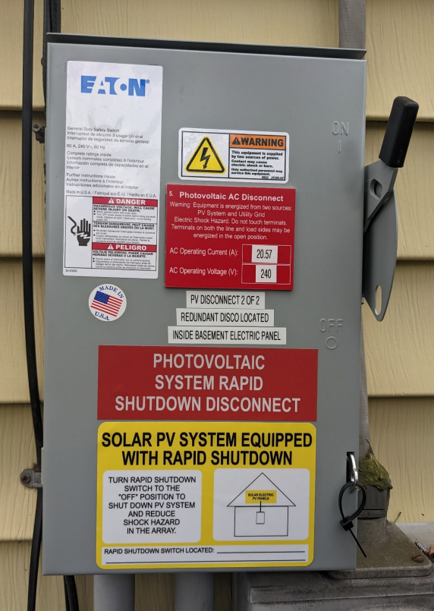
Notes:

Standalone AC Disconnect Wiring
Show all wiring details, nameplate, and terminations
Insert Photo(s) Here
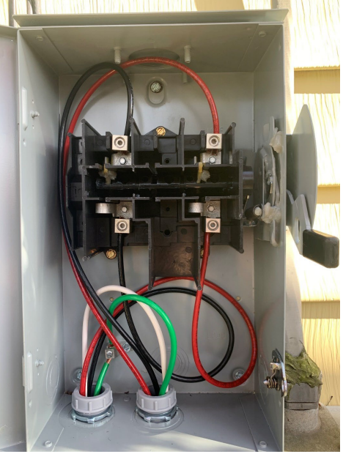
Notes:
Load Side Connection Main Service Panel Exterior (Door Open and Closed)
Show labeling detail, Main breaker rating , System Backfeed Breaker
Insert Photo(s) Here
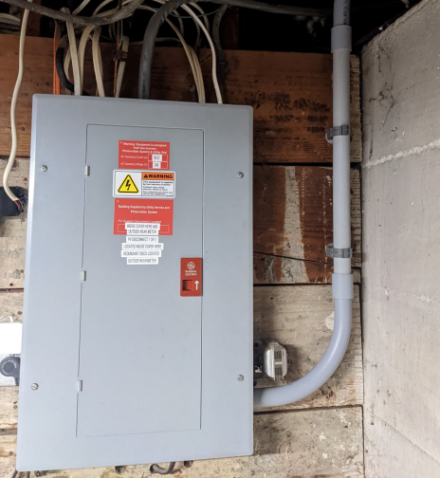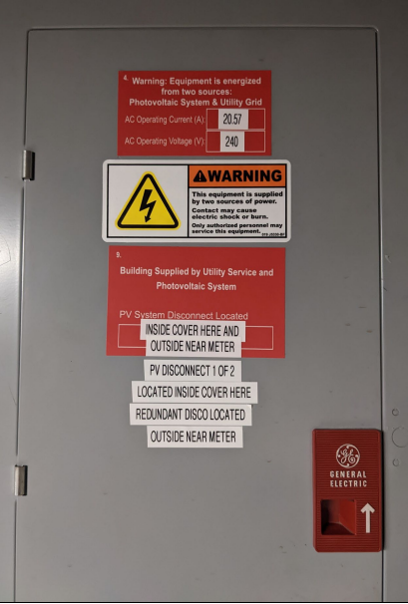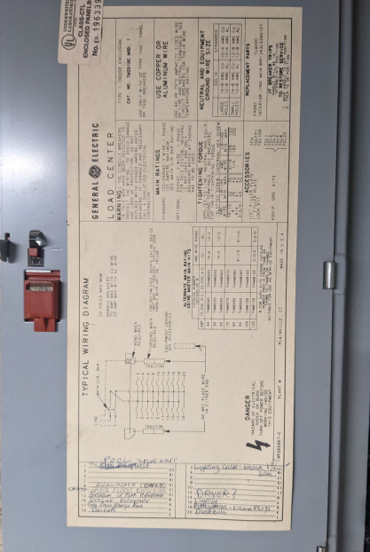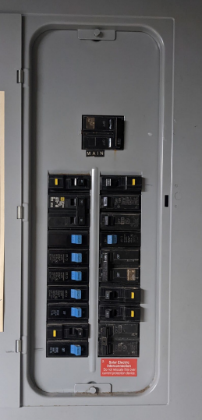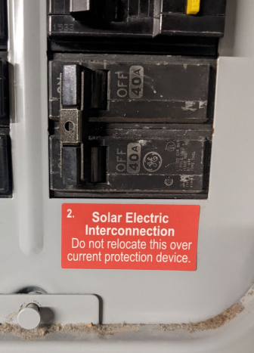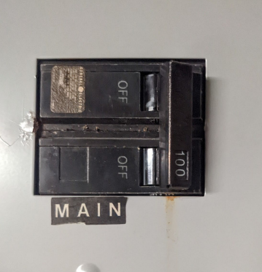
Notes:

Load Side Connection Main Service Panel Wiring
Show full wiring detail inside panel
Insert Photo(s) Here
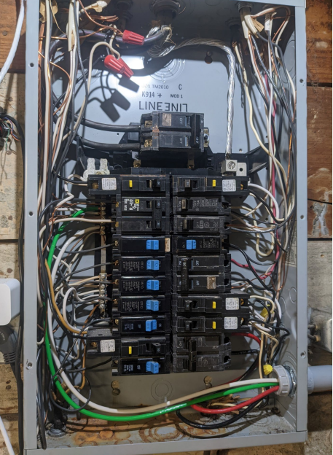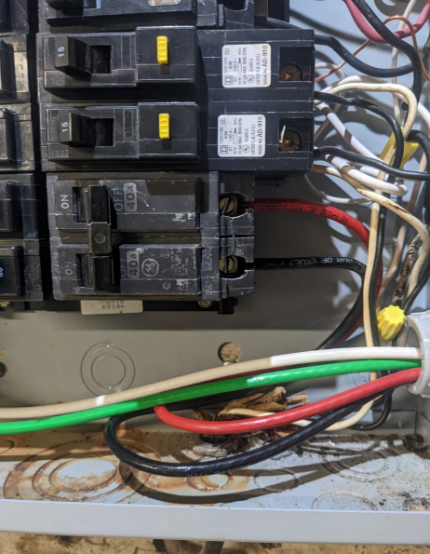
Notes:
Feeder Tap Connection
Show feeder tap interconnection/splice connector detail
Insert Photo(s) Here
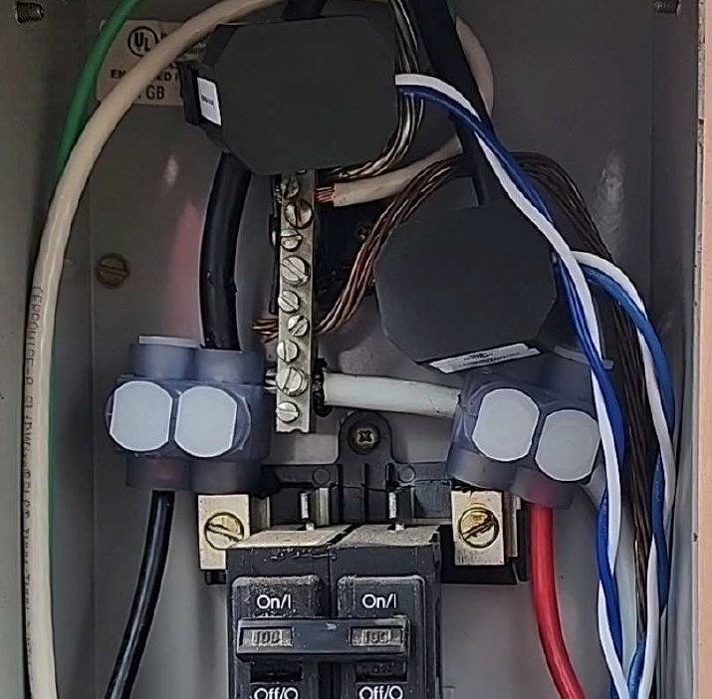
Notes:

Feeder Tap Connection Disconnect Exterior
Show labeling/nameplate detail
Insert Photo(s) Here
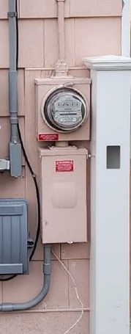
Notes:
Feeder Tap Connection Disconnect Wiring
Show all wiring, termination, nameplate, and fuse details
Insert Photo(s) Here
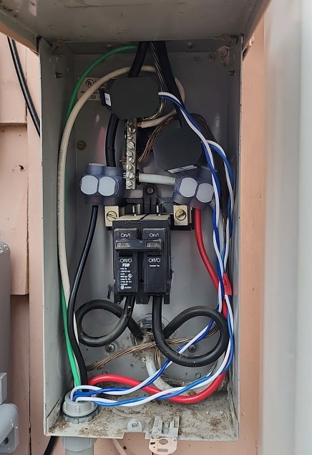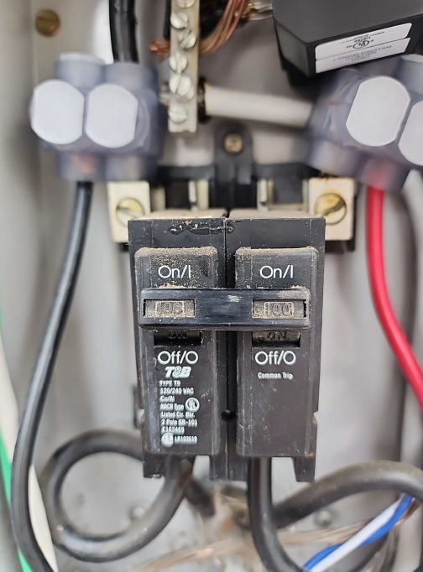
Notes:
Feeder Tap Connection Load panel/Panel Disconnect
Show labeling, nameplate detail, main breaker
Insert Photo(s) Here
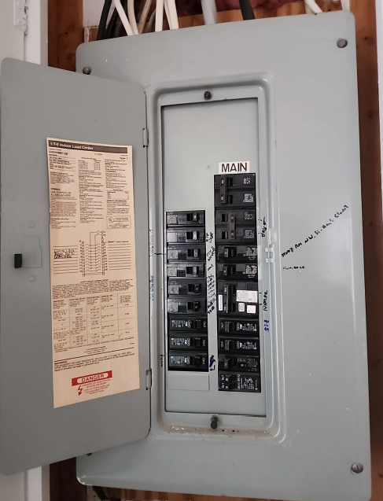
Notes:

Supply Side Connection Disconnect Exterior
Show labeling/nameplate detail
Insert Photo(s) Here
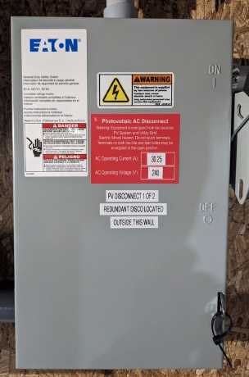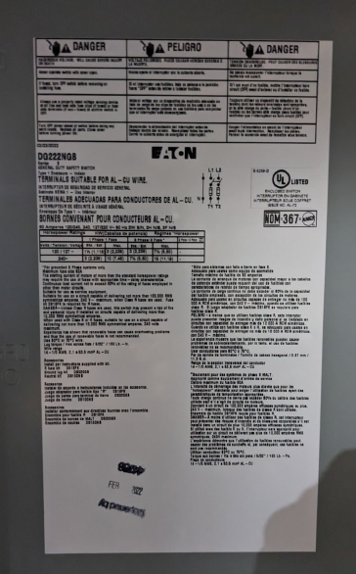
Notes:
Supply Side Connection Disconnect Wiring
Show all wiring, termination, nameplate, and fuse details. Ensure neutral terminal and green ground bonding screw are visible
Insert Photo(s) Here
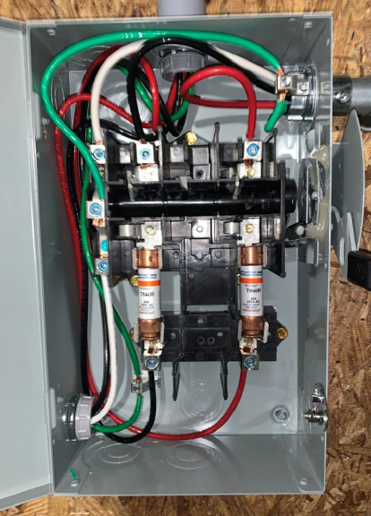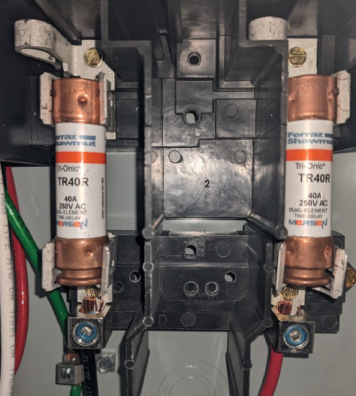
Notes:

Supply Side Connection Main Service Panel Exterior and Nameplate Photo(s)
Photo showing the busbar rating
Insert Photo(s) Here
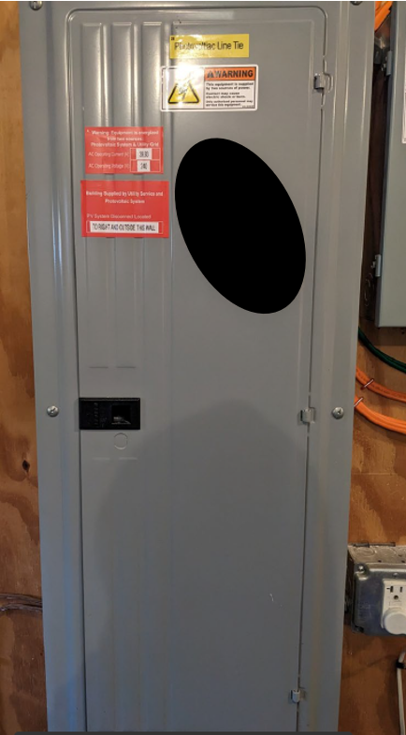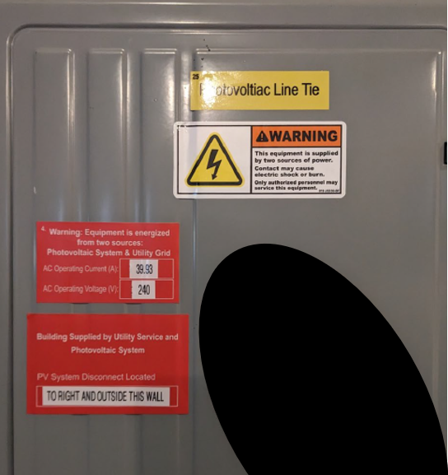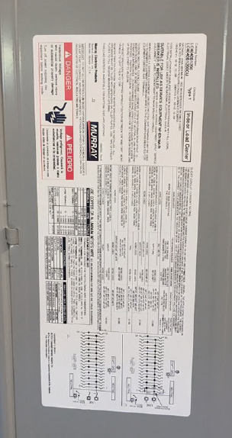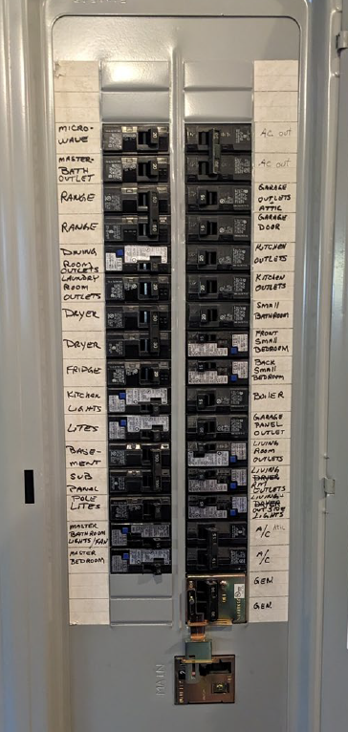
Notes:
Supply Side Connection
Show service entrance conductor interconnection/spice connector detail, main/service OCPD
Include images of genset / automatic transfer switches if present
Insert Photo(s) Here
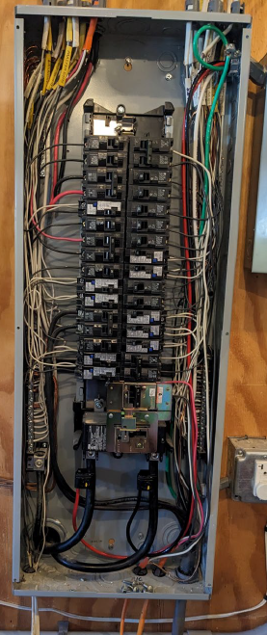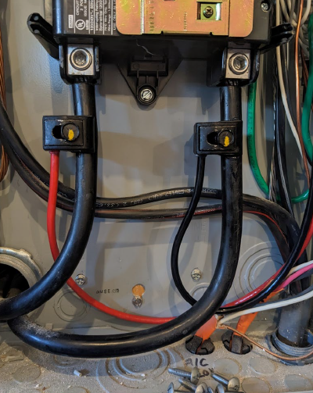
Notes:

Interconnection Standalone Main Service Disconnect
Insert Photo(s) Here
Notes:
Balance of System (BOS) Overview Photos
Show general location/configuration of PV System Equipment and Associated Distribution Equipment
Multiple photos may be needed
Insert Photo(s) Here
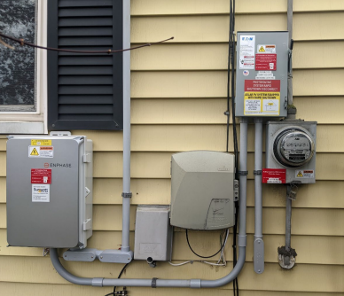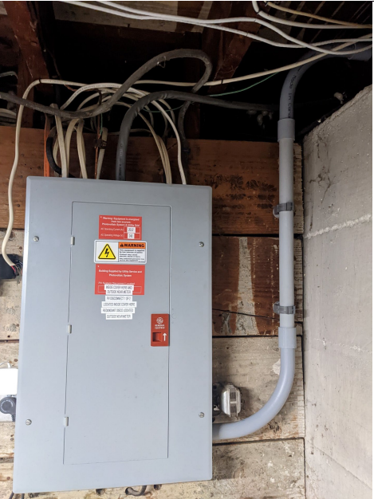

Notes:
Balance of System (BOS) Utility Meter Photos
Show location and nameplate of utility meter
Insert Photo(s) Here
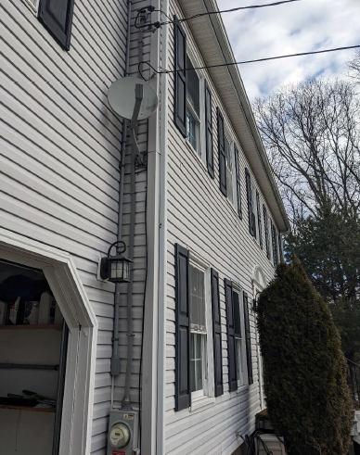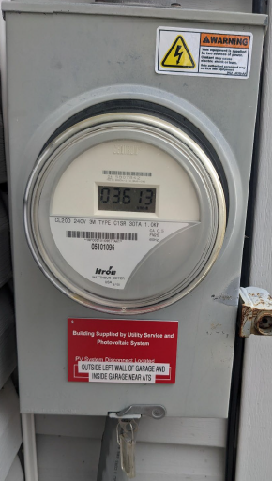
Notes:
Additional Photos
Notes:

